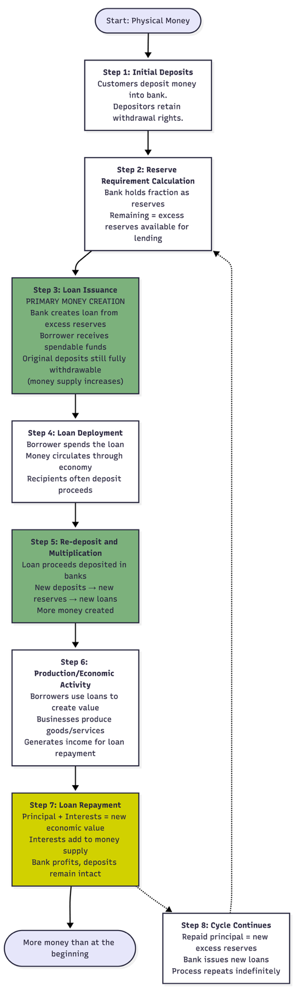
Money creation through credit
Step 1: Initial Deposits People put their money in the bank. The bank now holds the physical cash, but the depositors can still withdraw their money anytime.
Step 2: Reserve Requirement Calculation The bank must keep some money in its vault (about 25% of deposits) and can lend out the rest. If someone deposits $100, the bank keeps $25 and can lend $75.
Step 3: Loan Issuance - PRIMARY MONEY CREATION The bank lends out the $75 to a borrower. Now the original depositor still has $100 they can withdraw, AND the borrower has $75 they can spend. Money just appeared—$100 became $175 in the economy.
Step 4: Loan Deployment The borrower spends their $75 buying things or paying people. This money moves through the economy as people use it for transactions.
Step 5: Re-deposit and Multiplication Whoever received that $75 usually deposits it back into a bank. Now that bank can lend out most of it again, creating even more money. This repeats over and over, multiplying the original amount.
Step 6: Production/Economic Activity Borrowers use the loan money to run businesses, make products, or provide services. This work creates value and generates income they'll use to pay back the loan.
Step 7: Loan Repayment The borrower pays back the $75 (which disappears from the money supply) plus interest. The interest is extra money that came from the real value they created, adding to the total money in the system.
Step 8: Cycle Continues The $75 that was repaid becomes available to lend again. The bank makes a new loan, and the whole process starts over, continuously creating more money.
https://www.youtube.com/watch?v=8xzINLykprA

